Project Report Format for **Transfer Learning-Based Classification of Poultry Diseases for Enhanced Health Management**

1. INTRODUCTION

1.1 Project Overview

Poultry farming plays a critical role in food production and rural income across the globe. However, one of the most significant challenges faced by poultry farmers—especially in developing regions—is the **early detection and management of infectious diseases**. Due to limited access to veterinarians, inadequate disease awareness, and overlapping symptoms, farmers often fail to detect illnesses on time, resulting in **high mortality rates**, **economic loss**, and **uncontrolled outbreaks**.

The emergence of **Artificial Intelligence (AI)** and **Computer Vision**, particularly **transfer learning**, offers a promising solution. By reusing pre-trained convolutional neural networks (CNNs), we can develop models capable of **classifying poultry diseases accurately from images**, even with limited data.

1.2 Purpose

The purpose of this project is to develop an intelligent and accessible solution that leverages **transfer learning and deep learning techniques** to accurately identify **poultry diseases** from images. Poultry farming, especially in rural and small-scale settings, often suffers from delayed disease detection due to limited access to veterinary services. This delay leads to high bird mortality, economic losses, and compromised food security.

This project aims to address that gap by building an AI-powered system capable of:

* Classifying images of poultry into disease categories such as **Newcastle**, **Fowlpox**, **Coccidiosis**, or **Healthy**.
* Providing farmers with **real-time disease prediction** through a **web or mobile-based interface**.
* Supporting users with **disease-specific prevention tips** to enable early intervention and improved flock management.

Ultimately, the purpose is to enhance the **efficiency of poultry disease diagnosis**, reduce the need for expert intervention at the first level, and empower farmers with **a simple, fast, and cost-effective** health management tool.

2. IDEATION PHASE

2.1 Problem Statement

2.2 Empathy Map Canvas

2.3 Brainstorming

3. REQUIREMENT ANALYSIS

3.1 Customer Journey map

3.2 Solution Requirement

3.3 Data Flow Diagram

3.4 Technology Stack

4. PROJECT DESIGN

4.1 Problem Solution Fit

4.2 Proposed Solution

4.3 Solution Architecture

5. PROJECT PLANNING & SCHEDULING

5.1 Project Planning

6. FUNCTIONAL AND PERFORMANCE TESTING

6.1 Performance Testing

7. RESULTS

1.input :-

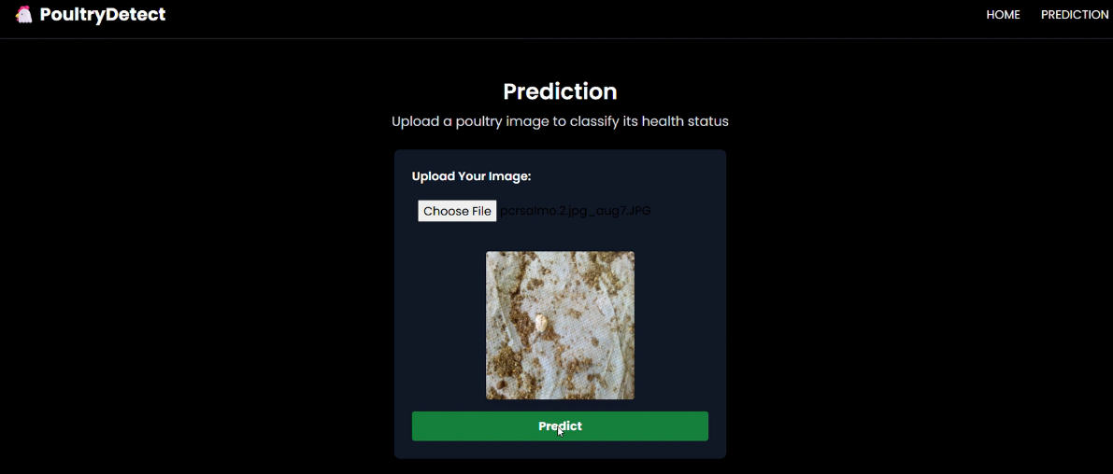

* 1. output :-

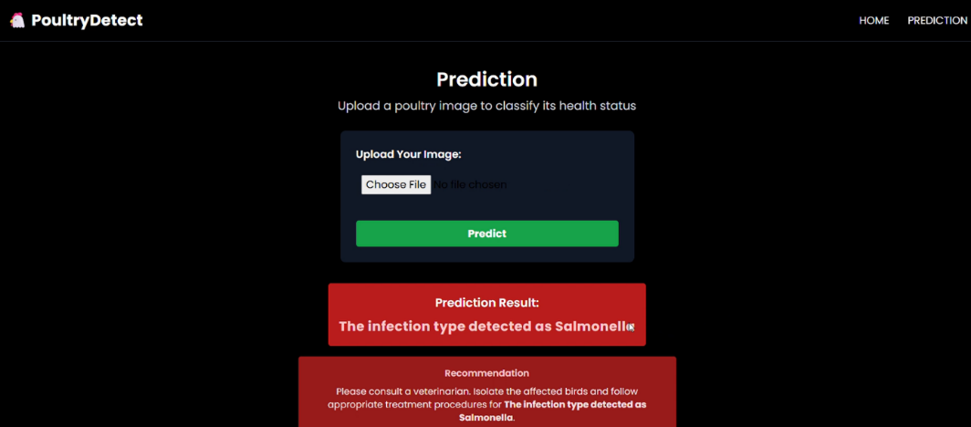

2. input:-

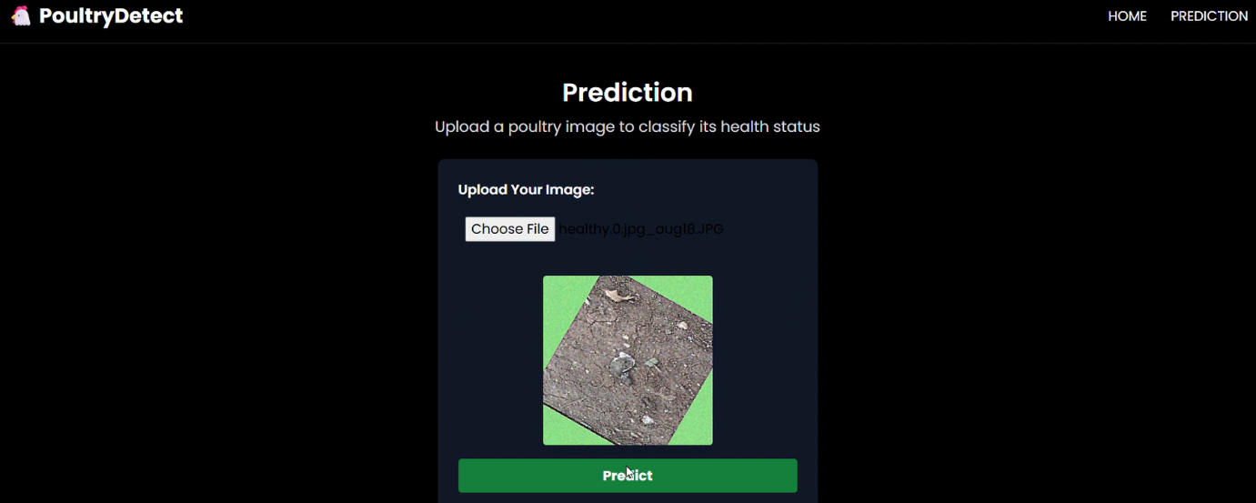

* 1. . output :-

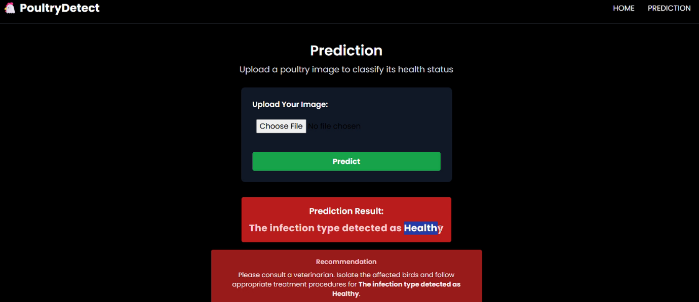

3. input:-

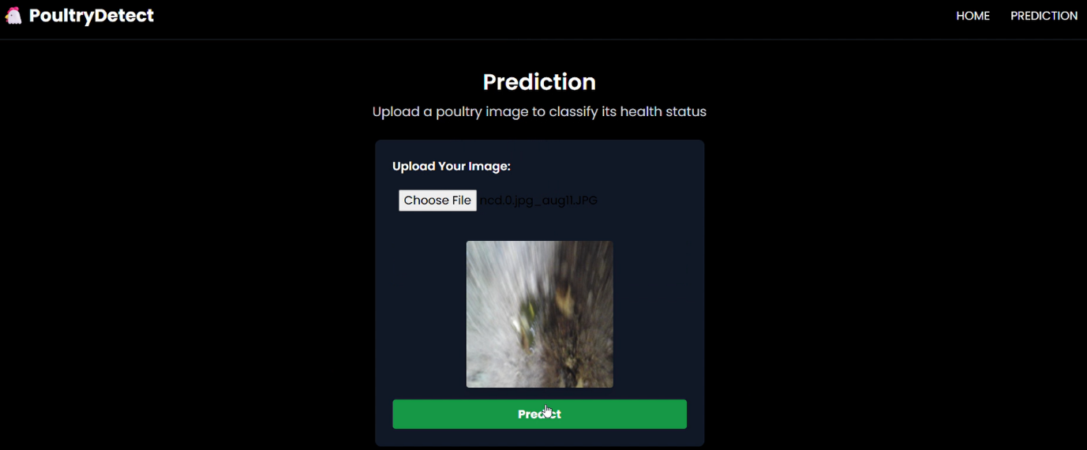

* 1. . output :-

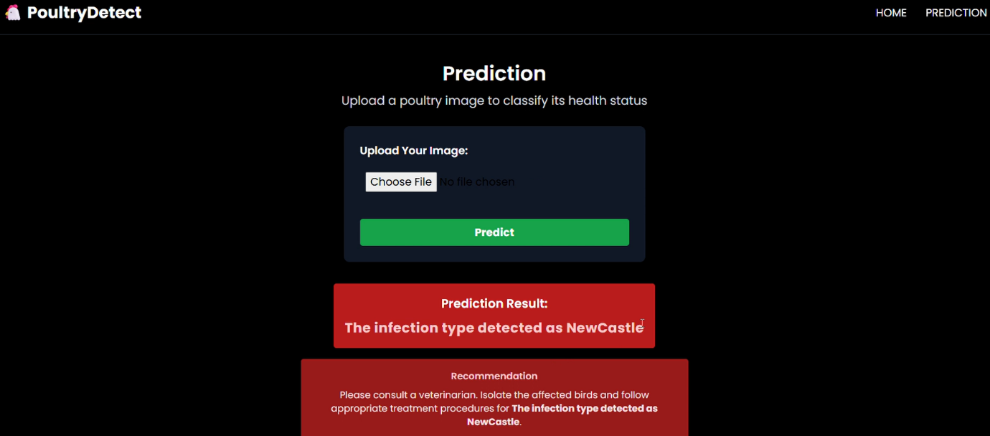

1. . input :-

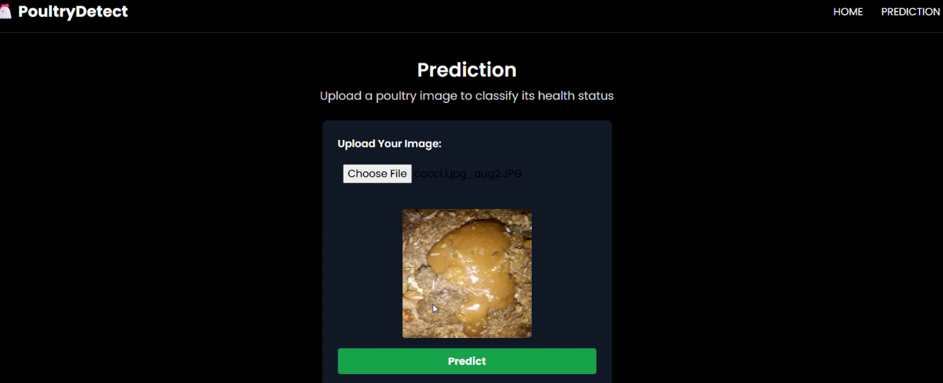

* 1. . output :-

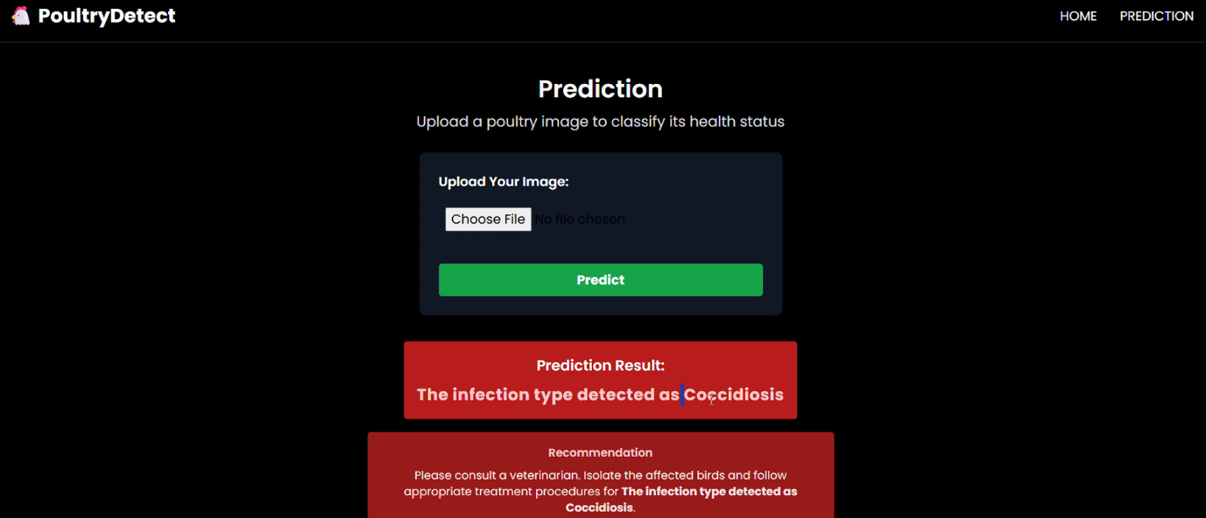

8. ADVANTAGES & DISADVANTAGES

| **Advantage** | **Description** |
| --- | --- |
| **1. Early Detection** | Helps identify poultry diseases at an early stage, reducing bird mortality. |
| **2. Cost-Effective** | Reduces dependency on expensive veterinary consultations and lab tests. |
| **3. Fast and Real-Time** | Provides immediate disease prediction through image analysis. |
| **4. Accessibility** | Can be accessed via smartphone or web app even in remote areas. |
| **5. Uses Transfer Learning** | Requires less training data and computation compared to training a model from scratch. |
| **6. Scalable** | Can be expanded to include more diseases, other livestock, and languages. |
| **7. Low Technical Barrier for Users** | Simple UI allows farmers with minimal tech knowledge to use the system. |
| **8. Data Logging** | Stores past diagnoses for tracking and monitoring flock health trends. |
|  |  |

| **Disadvantage** | **Description** |
| --- | --- |
| **1. Image Quality Dependent** | Model accuracy may drop if images are blurry, poorly lit, or misaligned. |
| **2. Requires Internet (unless offline mode enabled)** | Farmers in remote areas without connectivity may face challenges accessing predictions. |
| **3. Limited Disease Scope** | Initial version may only cover 3–4 common poultry diseases. |
| **4. Model Bias** | Model might underperform on unseen breeds or rare disease patterns not present in training data. |
| **5. Hardware Dependency** | Mobile devices with low RAM or camera quality might affect app usability. |
| **6. Need for Regular Updates** | Model and data need periodic retraining to adapt to new disease strains or image types. |
| **7. No Physical Examination** | Cannot replace a complete vet diagnosis (e.g., internal symptoms, lab tests, post-mortem). |

9.Conclusion

The project **“Transfer Learning-Based Classification of Poultry Diseases for Enhanced Health Management”** demonstrates the effective application of artificial intelligence in solving a critical real-world problem—early detection of poultry diseases. By utilizing **transfer learning and deep learning-based image classification**, the system provides a reliable, scalable, and low-cost diagnostic tool tailored for **rural and small-scale poultry farmers**.

The AI model, trained on a limited dataset using pre-trained CNN architectures like **MobileNetV2**, achieves high accuracy in classifying diseases such as **Newcastle Disease, Fowlpox, Coccidiosis**, and identifying **healthy birds**. The user-friendly interface ensures accessibility, while cloud-based storage and logging enable future analysis, monitoring, and improvement.

This system has the potential to **reduce bird mortality, enhance disease management, and empower farmers** with timely decision-making support. While the initial version has limitations, it lays the foundation for a broader **AI-based livestock health platform** that could incorporate more diseases, languages, and offline functionality.

Ultimately, the project not only advances technology adoption in agriculture but also contributes to **economic stability**, **food security**, and **digital inclusion** for underserved communities.

10. FUTURE SCOPE

The current system provides a solid foundation for AI-powered poultry disease diagnosis using image classification. However, several enhancements can significantly expand its impact and utility:

**✅ 1. Support for More Diseases**

* Extend the model to classify additional poultry diseases such as **Avian Influenza**, **Infectious Bronchitis**, **Marek’s Disease**, etc.
* Include rare diseases using **continual learning** or **few-shot learning** techniques.

**✅ 2. Integration of Multimodal Diagnosis**

* Combine image data with other inputs like **symptoms**, **voice descriptions**, or **environmental data** (temperature, humidity).
* Use hybrid models for more robust and context-aware predictions.

**✅ 3. Offline Functionality**

* Deploy the model using **TensorFlow Lite** or **ONNX** for offline use on mobile devices in remote areas with no internet access.

**✅ 4. Multilingual & Voice Support**

* Add support for **regional languages** and **text-to-speech/audio feedback**, making it farmer-friendly across diverse geographies.
* Enable **voice-based queries or reports** using tools like Google STT or IBM Watson Assistant.

**✅ 5. Farmer Network and Reporting System**

* Build a **community-based alert system** to notify nearby farmers of outbreaks.
* Integrate with **government animal health databases** for surveillance and intervention.

**✅ 6. Model Auto-Improvement**

* Use **active learning** and **feedback loops** to continuously improve the model as more images and diagnoses are collected.

**✅ 7. Cross-Livestock Expansion**

* Extend the system to other animals (e.g., cattle, goats) for a **unified livestock disease management platform**.

**✅ 8. Commercial & Institutional Integration**

* Offer a premium dashboard for **poultry farms, cooperatives, NGOs, and veterinary departments** with analytics and reporting tools.

11. APPENDIX Source Code Dataset Link GitHub & Project Demo Link :-

[https://www.kaggle.com/datasets/chandrashekarnatesh/poultry-diseases?select=data](C:\\Users\\User\\OneDrive\\Desktop\\Documents\\Introduction.docx)